Exp. 3. Simulation of Energy States of Quantum Dot using NanoHub

Name : Kishore R
Reg No : 192512008

Aim: To obtain the energy states of Quantum dots.
Case Study 1: Simulate the energy states of cylindrical quantum dots of X=15 nm, Y=10.5nm and
Z = 8 nm
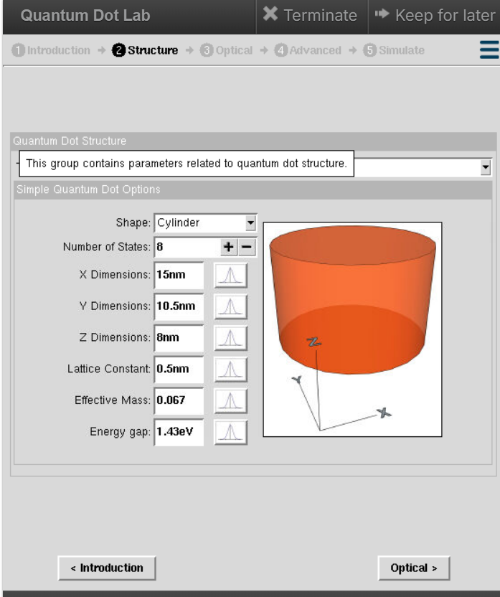
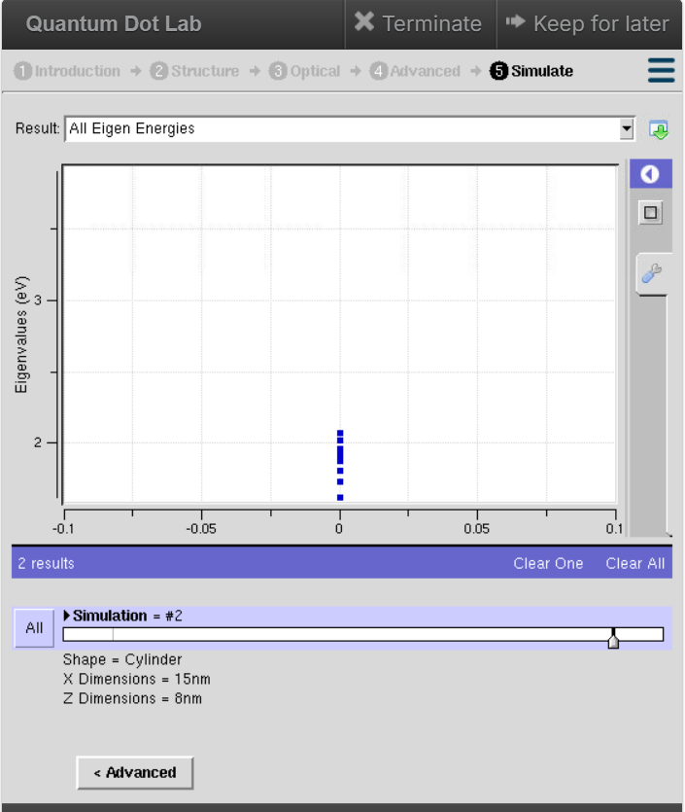

Case Study 2: Simulate the energy states of two layer cuboid quantum dots
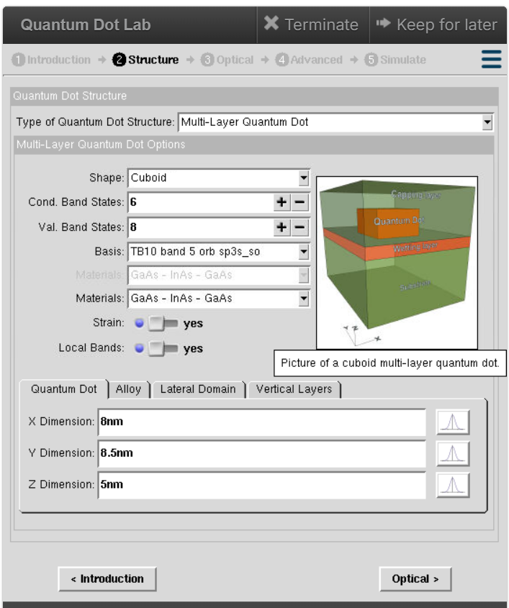
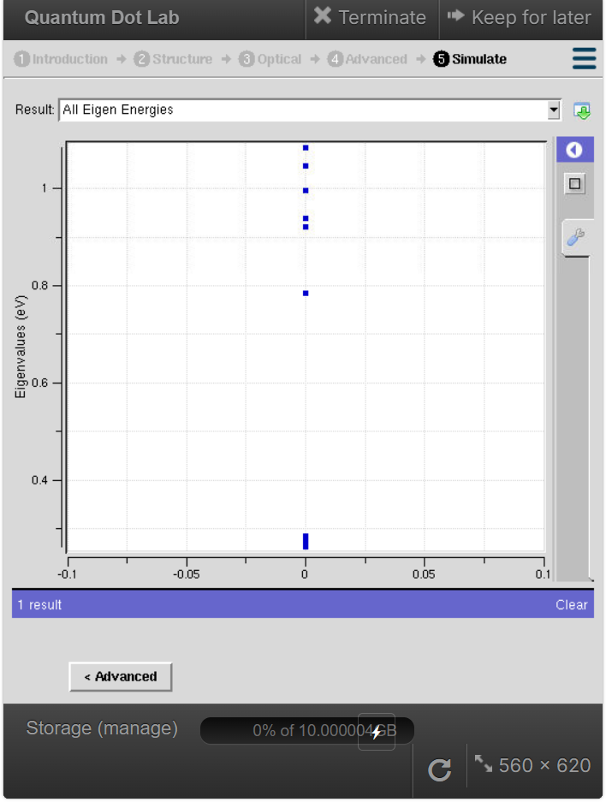

Result:
The Simulation of energy states of quantum dots is accomplished.

